METHODOLOGY

3.1 Overview and System Architecture
This study establishes a multi-stage predictive and decision-support framework to forecast hourly fine particulate matter (PM2.5) concentrations in Bath, UK. To bridge the gap between offline deep-learning modelling and real-world deployment, the proposed methodology transitions systematically from raw multi-source data ingestion to an automated Model Context Protocol (MCP) decision-support system.
The research design is organized across five sequential phases:
- Data Acquisition and Preprocessing: Heterogeneous stream integration, time synchronization, and graph-assisted data imputation.
- Feature Engineering and Model Exploration: Temporal embedding, meteorological feature construction, and progressive baseline development.
- Model Selection and Evaluation: Rigorous quantitative benchmarking across temporal metrics to isolate the optimal backbone.
- Spatio-Temporal Extension: Integration of Graph Neural Networks (GNN) to evaluate spatial road-network topology vs. local atmospheric dynamics.
- Operational Deployment: Integration of the optimal backbone into an MCP pipeline for 24-hour rolling predictions and real-time advisory generation.

3.2 Data Acquisition, Preprocessing, and Imputation
Predicting urban PM2.5 dynamics requires capturing complex environmental interactions. Multi-source data were collected at hourly intervals, comprising:
- Air Quality Readings: Historical hourly PM2.5 concentrations (µg/m³).
- Meteorological Variables: Surface temperature (°C), atmospheric pressure (hPa), relative humidity (%), total precipitation (mm), and wind vectors (speed and direction).
- Traffic Indicators: Vehicle count and flow metrics across local monitoring stations.
All time-series sequences were unified to a common hourly UTC timestamp.

3.2.1 Two-Step Sequential Imputation
To handle missingness without introducing temporal artifacts or synthetic bias, a custom two-step sequential imputation strategy was implemented:
Step 1: Graph-Based Traffic Imputation Missing values in spatial traffic sensors were recovered by exploiting the structural topology of the underlying road network. An adjacency matrix A in R^(N x N) was constructed based on inter-sensor distance and road connectivity. Missing sensor states were interpolated by weighting known neighbouring sensor states:
$${\overset{ˆ}{x}}_{i}\left(t\right)=\sum_{j∈N\left(i\right)}{\left[\left(\frac{w_{ij}}{\sum_{k∈N\left(i\right)}{w_{ik}}}\right)⋅x_{j}\left(t\right)\right]}$$

where N(i) denotes the spatial neighbourhood of sensor i, and w_ij represents the structural edge weight between sensors.
Step 2: K-Nearest Neighbours (KNN) Residual Imputation For non-traffic variables (meteorological parameters and isolated PM2.5 gaps) where structural network graphs do not apply, KNN imputation was performed on the temporal feature space. Missing values were estimated based on the distance-weighted mean of the k most similar temporal feature vectors (k = 5).

3.3 Feature Engineering and Progressive Model Development

3.3.1 Data Partitioning and Normalization
To reflect operational deployment and avoid data leakage, data scaling parameters (Min-Max bounds) were computed exclusively on the training split. The dataset was partitioned chronologically into training (70%), validation (15%), and test (15%) sets. Temporal ordering was strictly preserved during batch creation.

3.3.2 Cyclic Embeddings and Predictors
To assist deep learning architectures in recognizing multi-scale periodic patterns, temporal timestamps were transformed into continuous cyclic features using sine and cosine transformations:
$$t_{\text{sin}}=\sin\left(\frac{2π⋅t}{T}\right), t_{\text{cos}}=\cos\left(\frac{2π⋅t}{T}\right)$$
where t represents the temporal index and T is the corresponding periodicity (e.g., T = 24 for hour-of-day, T = 7 for day-of-week, T = 12 for month-of-year).

3.3.3 Progressive Architecture Progression
Models were evaluated across an increasing baseline complexity curve:
- Univariate Baselines: Initial models received only historical PM2.5 sequences. Standalone Long Short-Term Memory (LSTM) networks were evaluated for local gated sequential updates, alongside standalone Transformer encoders to test multi-head self-attention mechanisms over longer historical windows.
- Multivariate Expansion: Baselines were extended to incorporate meteorological covariates and cyclic temporal features. This step is grounded in atmospheric dispersion theory and empirical time-series literature (e.g., Zeng et al., 2026), which emphasizes that predicting atmospheric pollutants requires capturing both immediate local updates and extended seasonal/synoptic weather trends across varying forecast horizons.

3.4 Model Selection and Evaluation Framework

3.4.1 Quantitative Evaluation Metrics
Model accuracy was evaluated on unseen test data using three standard statistical metrics:
- Coefficient of Determination (R²): Quantifies the proportion of variance in PM2.5 explained by the model:
$$R^{2}=1-\frac{\sum_{i=1}^{n}{{\left(y_{i}-{\overset{ˆ}{y}}_{i}\right)}^{2}}}{\sum_{i=1}^{n}{{\left(y_{i}-\overline{y}\right)}^{2}}}$$
- Mean Absolute Error (MAE): Measures average error magnitude:
$$\text{MAE}=\frac{1}{n}\sum_{i=1}^{n}{\left|y_{i}-{\overset{ˆ}{y}}_{i}\right|}$$
- Root Mean Squared Error (RMSE): Measures sensitivity to large forecast deviations and extreme pollution spikes:
$$\text{RMSE}=\sqrt{\frac{1}{n}\sum_{i=1}^{n}{{\left(y_{i}-{\overset{ˆ}{y}}_{i}\right)}^{2}}}$$

3.4.2 The Backbone Architecture: Transformer-LSTM Hybrid
Across empirical test runs, the Optimised Transformer-LSTM Hybrid architecture outperformed both standalone LSTM and Transformer configurations.
[Placeholder image for the architecture]
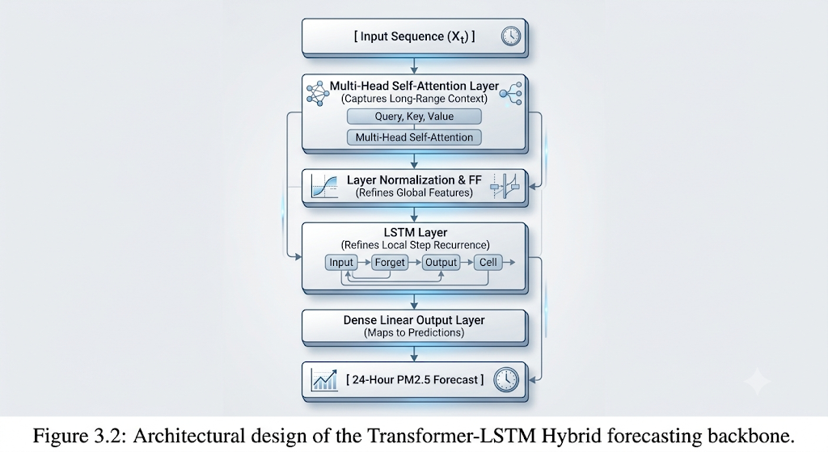
Figure 3.2: Architectural design of the Transformer-LSTM Hybrid forecasting backbone with a multi head attention layer(s) with normalized out puts into a performing LSTM layer(s) into the forecasting horizon.
The model uses a two-stage sequential design:
- Global Temporal Representation: The input sequence passes through a multi-head self-attention module to compute dependencies across all time steps, learning global synoptic trends.
- Local Recurrent Refinement: The self-attention feature map is passed directly into a recurrent LSTM layer, which acts as a temporal smoother to capture immediate, step-by-step local transitions.
This hybrid structure preserves temporal continuity while learning long-range atmospheric patterns, making it the primary forecasting backbone for downstream deployment.

3.5 Spatio-Temporal Graph Extension
To test whether explicit physical road topology improves performance over purely meteorological sequence modelling, a spatio-temporal Graph Neural Network (GNN) extension was implemented.

3.5.1 Architecture Design
The network combines spatial graph convolutions with temporal sequence encoders:
- Spatial Convolution: Traffic sensors are represented as nodes “V”, connected by weighted edges “E” based on geographical distance along the Bath road network. Graph convolutional layers aggregate spatial traffic states across neighbouring intersections.
- Temporal Fusion: Output embeddings from the GNN are concatenated with meteorological feature vectors and passed into a temporal sequence encoder.

3.5.2 Analysis of Empirical Findings (Negative Result)
Empirical evaluation showed that the GNN spatio-temporal architecture did not outperform the weather-informed Transformer-LSTM baseline within the target domain.
- Diagnostic Analysis: In the Bath urban micro-climate, PM2.5 variations are predominantly driven by regional meteorological dynamics (e.g., wind vector shifts, boundary layer height, temperature inversions) rather than localized, highly transient traffic bottlenecks.
- Methodological Significance: This negative result clarifies the domain boundaries of spatial modelling for air quality. It indicates that high-resolution weather features are sufficient for local PM2.5 forecasting in mid-sized urban geographies without requiring computationally intensive graph operations on sparse traffic networks.

3.6 MCP Pipeline
To operationalize the trained Transformer-LSTM backbone, the model was integrated into a Model Context Protocol (MCP) decision-support architecture, moving from offline evaluation to an automated public health application.

3.6.1 System Workflow
- 24-Hour Rolling Predictions: The backend engine automatically generates a 24-step hourly continuous forecast (ŷ_{t+1}, ..., ŷ_{t+24}) for PM2.5.
- Threshold Mapping: Predicted continuous values are mapped to standard Air Quality Index (AQI) risk tiers (Good, Fair, Poor, Very Poor).
- Contextual API Integration: Custom MCP server functions pull real-time weather alerts and live sensor streams from external web APIs.
- Natural Language Guidance Synthesis: The MCP layer synthesizes model forecasts with real-time contextual data to auto-generate human-readable public advisories (e.g., flagging elevated evening exposure risks due to incoming stagnant wind conditions).

